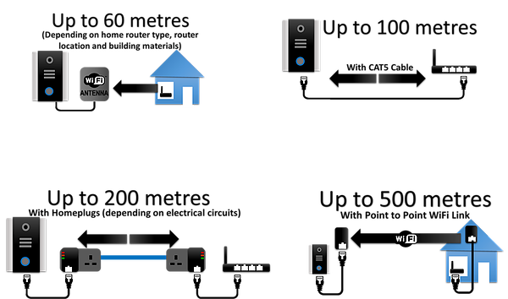
Range can be extended up to 500 metres by using various open market devices, such as Homeplug Technology, WiFi repeaters, and point to point links.

Always conduct a site survey before quoting this system.

